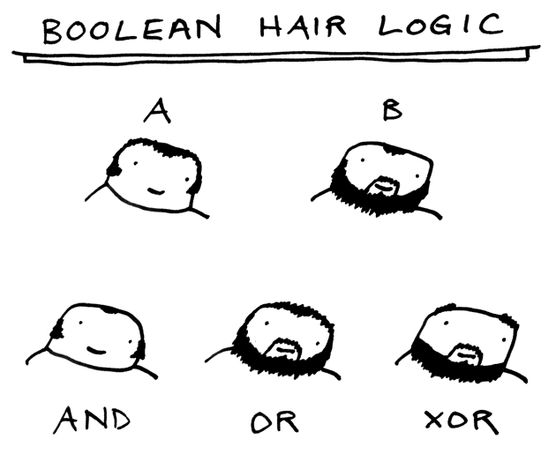

http://www.toothpastefordinner.com/071310/boolean-hair-logic.gif
July 14, 2010

